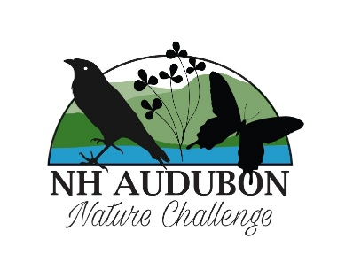
NH Audubon Nature Challenge
FAQs

Q. What is the NH Audubon Nature Challenge?
A. This project is a BioBlitz, which lasts seven days, in which we are asking participants to submit observations of all the wildlife and plant life they are seeing on our sanctuaries. You can view the included sanctuaries on the NH Audubon Nature Challenge webpage.
Q. What is a BioBlitz?
A. A BioBlitz is typically an event for a short duration in which participants are asked to record observations of everything they are seeing at a particular location. This includes mammals, birds, reptiles, amphibians, insects, mollusks, trees, shrubs, flowers, mosses, slime molds, mushrooms, etc.
Q. How do I participate in the NH Audubon Nature Challenge?
A. Visit one or more of the included sanctuaries from Sunday to Saturday during the challenge and submit your observations. Bird observations should be submitted using eBird, and all other submissions should be submitted using iNaturalist.
Q. What are the dates of the NH Audubon Nature Challenge?
A. This year, the dates are Sunday June 22 – Saturday June 28, 2025.
Q. How do I submit using eBird and iNaturalist?
A. You can view our webinar reviewing how to sign up for the free eBird and iNaturalist accounts at the link below, or you can use the other links specific to each platform. Both eBird and iNaturalist are free to use and can be used on a mobile device or a desktop/laptop.
Q. How will you get the observations and how will they be used?
A. As admins, NH Audubon will pull reporting for submitted observations in eBird and iNaturalist, compiling them into lands inventories by sanctuary location. These observations will be used to analyze what species are on our sanctuaries, which will be examined as we make future lands management strategies to even better support the wildlife using or residing on the land. This information will also be shared with participants after the event (once it is collected and organized) so participants can see the results of the project.
Q. When using iNaturalist, will my observation automatically be added to the project or do I need to join the NH Audubon Nature Challenge project to participate?
A. You do not need to join the iNaturalist project to have your observations included, although we would love you to join the project! When you visit one of the included sanctuaries between June 22 and June 28, your observations in iNaturalist will automatically be included.
However, if you are submitting through eBird, you will need to share your checklist with NHA_Nature_Challenge.
Q. How do I join the iNaturalist NH Audubon Nature Challenge BioBlitz project?
A. If you are using a desktop or laptop, click on “Community” at the top of the screen and go to “Projects.” You can search for “NH Audubon Nature Challenge” in the search bar, select the result (there will only be one) and click “Join” in the upper right corner. You’ll be taken to a page with a couple of selections and then you will select “Yes, I want to join.”
If you are using a mobile device and iNaturalist Classic, select “Projects” at the bottom of the screen in the app and then click on the magnifying glass to search for “NH Audubon Nature Challenge.” At the top of the screen will be a “Join” button. Confirm that you want to join.
If you are using a mobile device and the updated iNaturalist app, select the hamburger menu on the lower left of your screen and select “Projects.” Search for the challenge, scroll down the page, and select “Join.” Confirm that you want to join.
Q. Do I have to have a photo of a species to make an observation?
A. In eBird, media is not required for your checklist; however, if you are making an observation of an uncommon or rare bird and are able to get a photo, this is very helpful to the eBird reviewer in accepting your observation. In case you cannot get a photo, you can also take a sound recording or add detailed notes about the bird’s field marks and habitat.
In iNaturalist, there are three levels of observations: Casual, Needs ID, and Research Grade. Casual Grade observations are those without any supporting evidence, and although iNaturalist accepts them, they will not be added to the project because they cannot be used in support of scientific research. However, if you cannot get a photo, you can also use sound recordings as evidence of an observation. Most observations will be posted as “Needs ID,” and then as the iNaturalist community members review and comment on your observations, they can become “Research Grade,” which is the highest designation and what scientists use to support their conservation research projects around the world.
Q. Does iNaturalist automatically know my location when I submit an observation?
A. If you are submitting live through the app on your phone and you have not disabled your location services, iNaturalist will know the location of your observation and you do not need to choose it. However, if you are using a DSLR camera or a phone without location services, there are a few different methods you can use to save your location for submission to iNaturalist after your visit.
1. As you are taking photos, you can take a photo of your camera’s compass screen after each individual observation, which will have the latitude and longitude of where you were for that observation and can be used later to pinpoint location.
2. If you have a hiking watch, you can turn on the tracking and save the track. If you import photos into Adobe Lightroom, you can also import a GPS track and auto-tag photos with specific coordinates. Then as you add photos to an observation, the location will populate.
Q. Will observations be included that are taken from watercraft along the shoreline of a sanctuary, for those properties that allow water access?
A. For eBird, you can select the sanctuary location you want to post to and then share your checklist with NHA_Nature_Challenge, so everything you see will be part of the project.
For iNaturalist, we have worked to expand the sanctuary boundaries to include the shoreline (or entire water body when appropriate) of sanctuaries that abut water, so all your shoreline observations will be included.
Q. You mentioned in the webinar that Geoprivacy settings can be changed in iNaturalist. How do you do that?
A. When you are making a submission, one of the sections, along with location, date and species, is Geoprivacy. For the NH Audubon Nature Challenge, we ask that you keep your geoprivacy set to “Open,” but for sensitive locations (such as your home or place of employment), you can select “Obscure” or “Private.” Here are some screenshots of how to change it.
iNat Classic App iNaturalist updated App
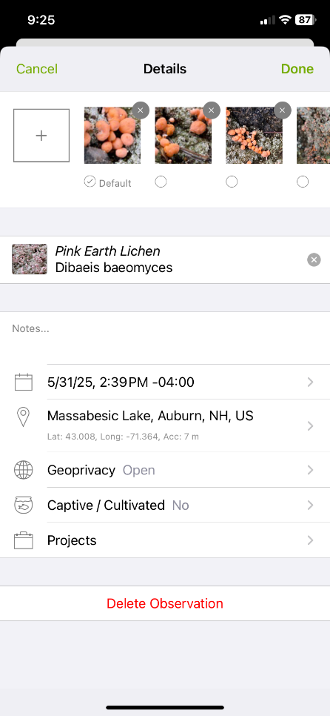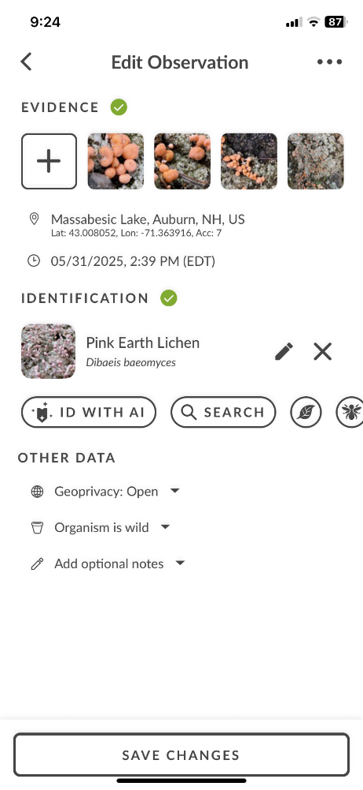

Q. What if many participants go to some sanctuaries but no one goes to others?
A. We have a few guided tours scheduled throughout the week to try and ensure observations are made at a diversity of sanctuary properties. However, since this is the first year, we will learn a lot based on participation and attendance and may look at some changes for the future based on how many people visit each sanctuary this year.
Q. Where can I find additional resources on the challenge, eBird, and iNaturalist?
A. Here are some additional resources that were shared during the webinar -
- iNaturalist.org
  - https://www.inaturalist.org/taxa (to explore species categories)
  - https://help.inaturalist.org/en/support/home (to find articles and videos
- eBird.org
  - https://support.ebird.org/
- NH Audubon Nature Challenge
  - https://nhaudubon.org/center-and-events/nh-audubon-nature-challenge/ (RSVP for the event, see our QuickStart Guides, check out the Schedule of Events)
- Contact Information to share your photos
  - emedia@nhaudubon.org
  - https://www.facebook.com/nh.Audubon
  - https://www.Instagram.com/nhaudubon/
    - #NHAudubonNatureChallenge
    - #LetsGoOutside

